**SPRING CORE AND MAVEN**

**Exercise 1: Configuring a Basic Spring Application**

**Scenario:**

Your company is developing a web application for managing a library. You need to use the Spring Framework to handle the backend operations.

**Steps:**

1. **Set Up a Spring Project:**
   * Create a Maven project named **LibraryManagement**.
   * Add Spring Core dependencies in the **pom.xml** file.
2. **Configure the Application Context:**
   * Create an XML configuration file named **applicationContext.xml** in the **src/main/resources** directory.
   * Define beans for **BookService** and **BookRepository** in the XML file.
3. **Define Service and Repository Classes:**
   * Create a package **com.library.service** and add a class **BookService**.
   * Create a package **com.library.repository** and add a class **BookRepository**.
4. **Run the Application:**
   * Create a main class to load the Spring context and test the configuration.

**Source Code:**

**Pom.xml**

<project xmlns="http://maven.apache.org/POM/4.0.0" xmlns:xsi="http://www.w3.org/2001/XMLSchema-instance"  
 xsi:schemaLocation="http://maven.apache.org/POM/4.0.0 http://maven.apache.org/xsd/maven-4.0.0.xsd">  
 <modelVersion>4.0.0</modelVersion>  
 <groupId>org.example</groupId>  
 <artifactId>LibraryManagement</artifactId>  
 <version>1.0-SNAPSHOT</version>  
 <packaging>jar</packaging>  
 <name>LibraryManagement</name>  
 <url>http://maven.apache.org</url>  
 <properties>  
 <project.build.sourceEncoding>UTF8</project.build.sourceEncoding>  
 </properties>  
 <dependencies>  
 <dependency>  
 <groupId>junit</groupId>  
 <artifactId>junit</artifactId>  
 <version>3.8.1</version>  
 <scope>test</scope>  
 </dependency>  
 <dependency>  
 <groupId>org.springframework</groupId>  
 <artifactId>spring-context</artifactId>  
 <version>5.3.34</version>  
 </dependency>  
 </dependencies>  
</project>

**applicationContext.xml**

<?xml version="1.0" encoding="UTF-8"?>  
<beans xmlns="http://www.springframework.org/schema/beans"  
 xmlns:xsi="http://www.w3.org/2001/XMLSchema-instance"  
 xsi:schemaLocation="  
 http://www.springframework.org/schema/beans  
 http://www.springframework.org/schema/beans/spring-beans.xsd">  
 <bean id="bookRepository" class="Repository.BookRepository" />  
 <bean id="bookService" class="Service.BookService" >  
 <property name="bookRepository" ref="bookRepository"/>  
 </bean>  
</beans>

**App.java**

package org.example;  
import Service.BookService;  
import org.springframework.context.ApplicationContext;  
import org.springframework.context.support.ClassPathXmlApplicationContext;  
public class App {  
 public static void main(String[] args) {  
 ApplicationContext context = new ClassPathXmlApplicationContext("applicationContext.xml");  
 BookService bookService = (BookService) context.getBean("bookService");  
 bookService.addBook("Getting started with Spring");  
 }  
}

**BookRepository.java**

package Repository;  
  
public class BookRepository {  
 public void save(String book) {  
 System.*out*.println("Saved the book \"" + book+"\" in the repository");  
 }  
}

**BookService.java**

package Service;  
import Repository.BookRepository;  
public class BookService {  
 private BookRepository bookRepository;  
 public void setBookRepository(BookRepository bookRepository) {  
 this.bookRepository = bookRepository;  
 }  
 public void addBook(String book) {  
 System.*out*.println("Adding book with title \" " + book+" \"");  
 bookRepository.save(book);  
 }  
 }

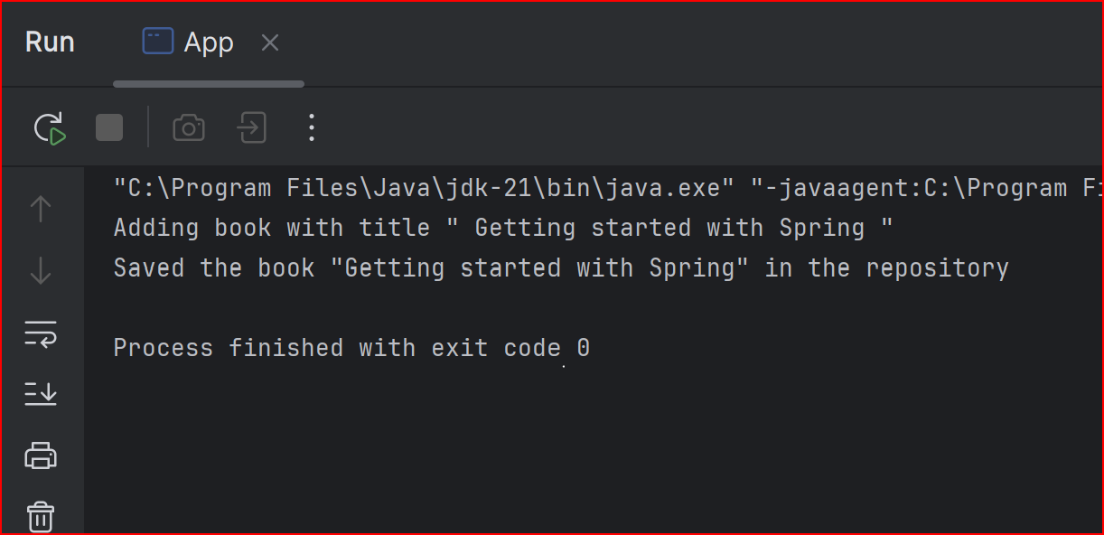**OUTPUT:**

**Exercise 2: Implementing Dependency Injection**

**Scenario:**

In the library management application, you need to manage the dependencies between the BookService and BookRepository classes using Spring's IoC and DI.

**Steps:**

1. **Modify the XML Configuration:**
   * Update **applicationContext.xml** to wire **BookRepository** into **BookService**.
2. **Update the BookService Class:**
   * Ensure that **BookService** class has a setter method for **BookRepository**.
3. **Test the Configuration:**
   * Run the **LibraryManagementApplication** main class to verify the dependency injection.

**Source Code:**

**Pom.xml**

<project xmlns="http://maven.apache.org/POM/4.0.0" xmlns:xsi="http://www.w3.org/2001/XMLSchema-instance"  
 xsi:schemaLocation="http://maven.apache.org/POM/4.0.0 http://maven.apache.org/xsd/maven-4.0.0.xsd">  
 <modelVersion>4.0.0</modelVersion>  
 <groupId>org.example</groupId>  
 <artifactId>LibraryManagement</artifactId>  
 <version>1.0-SNAPSHOT</version>  
 <packaging>jar</packaging>  
 <name>LibraryManagement</name>  
 <url>http://maven.apache.org</url>  
 <properties>  
 <project.build.sourceEncoding>UTF8</project.build.sourceEncoding>  
 </properties>  
 <dependencies>  
 <dependency>  
 <groupId>junit</groupId>  
 <artifactId>junit</artifactId>  
 <version>3.8.1</version>  
 <scope>test</scope>  
 </dependency>  
 <dependency>  
 <groupId>org.springframework</groupId>  
 <artifactId>spring-context</artifactId>  
 <version>5.3.34</version>  
 </dependency>  
 </dependencies>  
</project>

**applicationContext.xml**

<?xml version="1.0" encoding="UTF-8"?>  
<beans xmlns="http://www.springframework.org/schema/beans"  
 xmlns:xsi="http://www.w3.org/2001/XMLSchema-instance"  
 xsi:schemaLocation="  
 http://www.springframework.org/schema/beans  
 http://www.springframework.org/schema/beans/spring-beans.xsd">  
 <bean id="bookRepository" class="Repository.BookRepository" />  
 <bean id="bookService" class="Service.BookService" autowire=”byName">  
 </bean>  
</beans>

**App.java**

package org.example;  
import Service.BookService;  
import org.springframework.context.ApplicationContext;  
import org.springframework.context.support.ClassPathXmlApplicationContext;  
public class App {  
 public static void main(String[] args) {  
 ApplicationContext context = new ClassPathXmlApplicationContext("applicationContext.xml");  
 BookService bookService = (BookService) context.getBean("bookService");  
 bookService.addBook("Getting started with Spring");  
 }  
}

**BookRepository.java**

package Repository;  
  
public class BookRepository {  
 public void save(String book) {  
 System.*out*.println("Saved the book \"" + book+"\" in the repository");  
 }  
}

**BookService.java**

package Service;  
import Repository.BookRepository;  
public class BookService {  
 private BookRepository bookRepository;  
 public void setBookRepository(BookRepository bookRepository) {  
 this.bookRepository = bookRepository;  
 }  
 public void addBook(String book) {  
 System.*out*.println("Adding book with title \" " + book+" \"");  
 bookRepository.save(book);  
 }  
 }

**OUTPUT:**

**Exercise 4: Creating and Configuring a Maven Project**

**Scenario:**

You need to set up a new Maven project for the library management application and add Spring dependencies.

**Steps:**

1. **Create a New Maven Project:**
   * Create a new Maven project named **LibraryManagement**.
2. **Add Spring Dependencies in pom.xml:**
   * Include dependencies for Spring Context, Spring AOP, and Spring WebMVC.
3. **Configure Maven Plugins:**
   * Configure the Maven Compiler Plugin for Java version 1.8 in the pom.xml file.

**Source Code:**

**pom.xml**

<project xmlns="http://maven.apache.org/POM/4.0.0" xmlns:xsi="http://www.w3.org/2001/XMLSchema-instance"  
 xsi:schemaLocation="http://maven.apache.org/POM/4.0.0 http://maven.apache.org/xsd/maven-4.0.0.xsd">  
 <modelVersion>4.0.0</modelVersion>  
  
 <groupId>org.example</groupId>  
 <artifactId>LibraryManagement2</artifactId>  
 <version>1.0-SNAPSHOT</version>  
 <packaging>jar</packaging>  
  
 <name>LibraryManagement2</name>  
 <url>http://maven.apache.org</url>  
  
 <properties>  
 <project.build.sourceEncoding>UTF-8</project.build.sourceEncoding>  
 </properties>  
  
 <dependencies>  
 <dependency>  
 <groupId>junit</groupId>  
 <artifactId>junit</artifactId>  
 <version>3.8.1</version>  
 <scope>test</scope>  
 </dependency>  
 <dependency>  
 <groupId>org.springframework</groupId>  
 <artifactId>spring-context</artifactId>  
 <version>5.3.34</version>  
 </dependency>  
  
 <!-- Spring AOP -->  
 <dependency>  
 <groupId>org.springframework</groupId>  
 <artifactId>spring-aop</artifactId>  
 <version>5.3.34</version>  
 </dependency>  
  
 <!-- Spring Web MVC -->  
 <dependency>  
 <groupId>org.springframework</groupId>  
 <artifactId>spring-webmvc</artifactId>  
 <version>5.3.34</version>  
 </dependency>  
  
 <!-- Servlet API (for Spring MVC) -->  
 <dependency>  
 <groupId>jakarta.servlet</groupId>  
 <artifactId>jakarta.servlet-api</artifactId>  
 <version>5.0.0</version>  
 <scope>provided</scope>  
 </dependency>  
 </dependencies>  
 <build>  
 <plugins>  
 <!-- Maven Compiler Plugin -->  
 <plugin>  
 <groupId>org.apache.maven.plugins</groupId>  
 <artifactId>maven-compiler-plugin</artifactId>  
 <version>3.11.0</version>  
 <configuration>  
 <source>1.8</source> <!-- Java source code version -->  
 <target>1.8</target> <!-- Java bytecode version -->  
 </configuration>  
 </plugin>  
 </plugins>  
 </build>  
</project>

**App.java**

package org.example;  
public class App   
{  
 public static void main( String[] args )  
 {  
 System.*out*.println( "Hello World!" );  
 }  
}

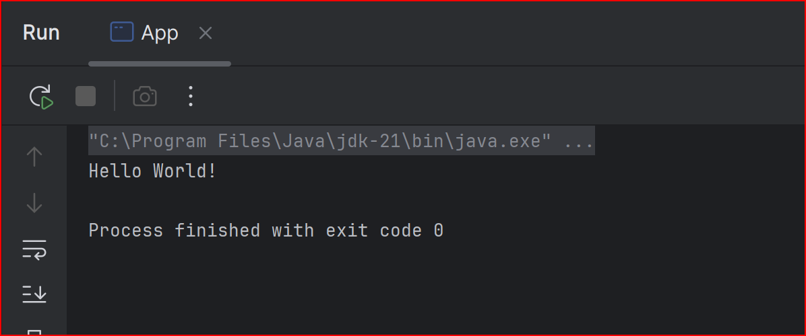**OUTPUT:**